Set Up Ingestion API Connector :
- In Data Cloud, click Setup, and then select Data Cloud Setup.
- Under Salesforce Integrations, select Ingestion API.(used to capture different types of data)
Click New Click Save.
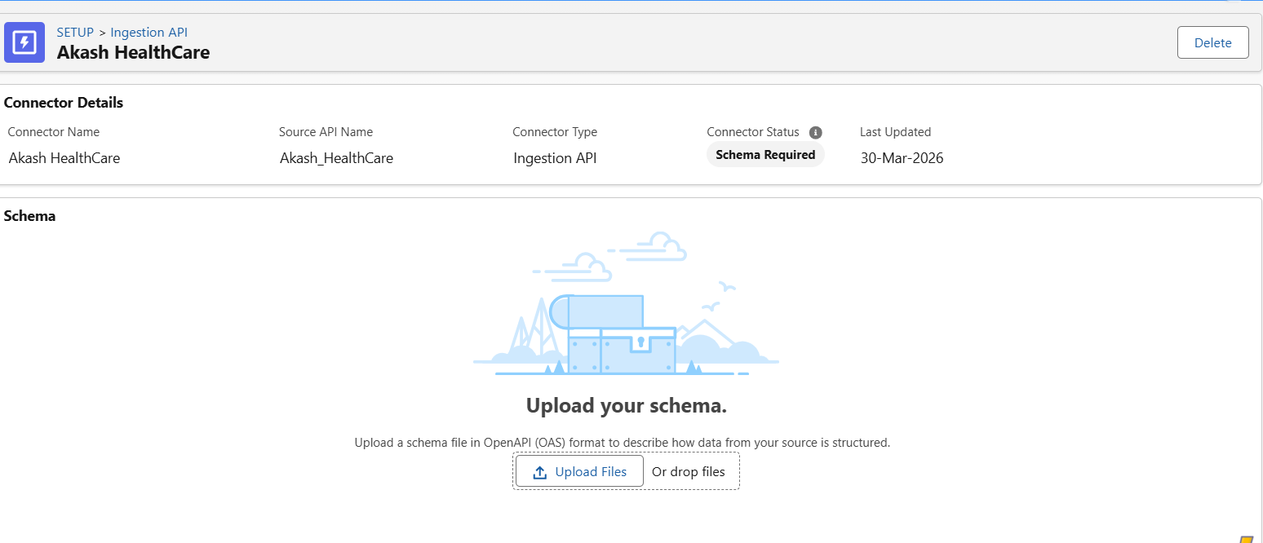upload a schema file in OpenAPI (OAS) format with a .yaml file extension.
(Define what kind of Data is flowing in between both the systems)
Below is .yaml file format
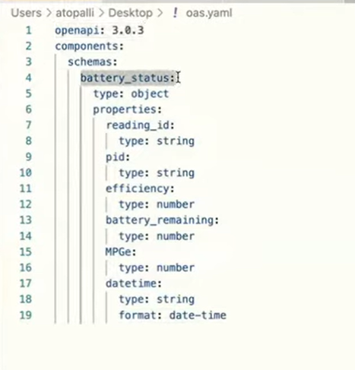

https://developer.salesforce.com/docs/data/data-cloud-int/guide/c360-a-ingestion-api-schema-req.html
guidance for schema ( .yaml ) file
- Create an Ingestion API Data Stream
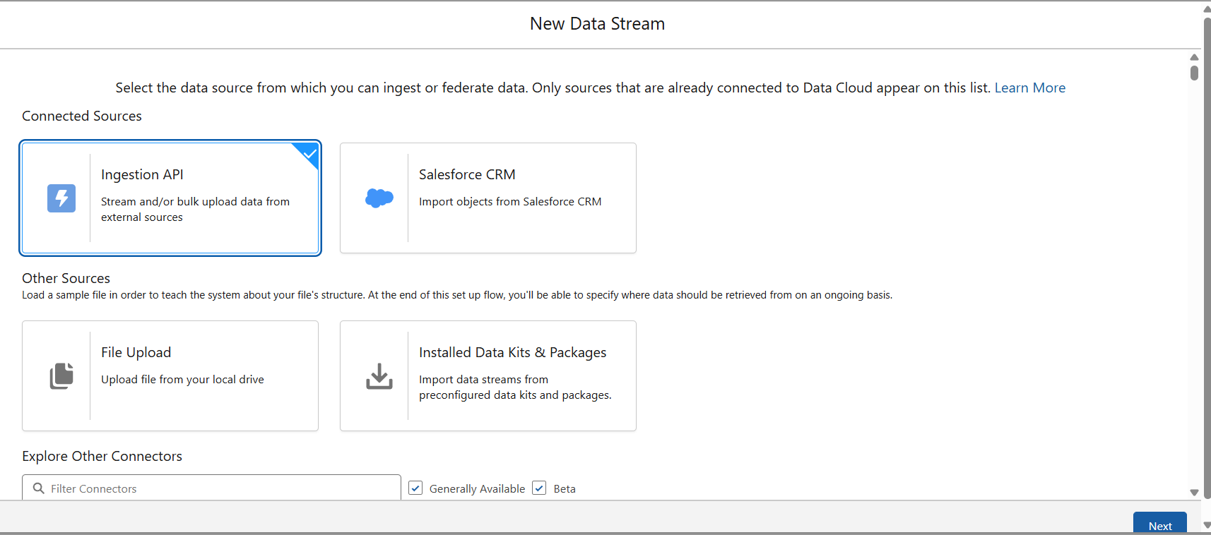

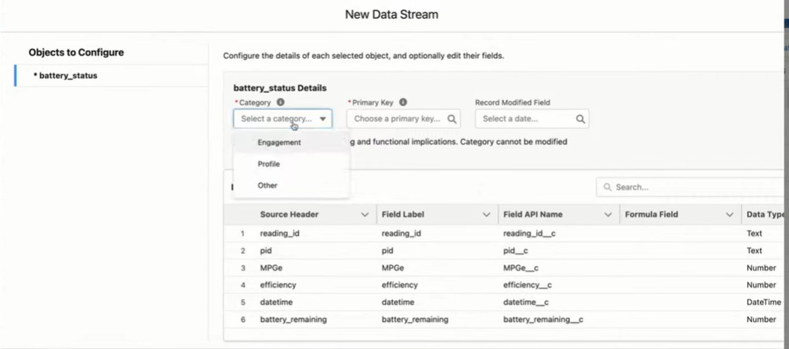

- For Primary Key, select the field to use to uniquely identify a record. For more information.
- Select the object’s category (Profile, Engagement, Other)
- For Record Modified Field, select the field that indicates when the incoming record was last modified.
This field is available only for Profile and Other category objects.

Profile
Used for datasets containing identifiable individuals, accounts, or entities that serve as the base for segmentation.

Engagement
Used for time-based event data (with Date/DateTime) that captures interactions or activities over time.

Other
Used for supporting datasets related to Profile or Engagement that are not primary entities for segmentation or unification.

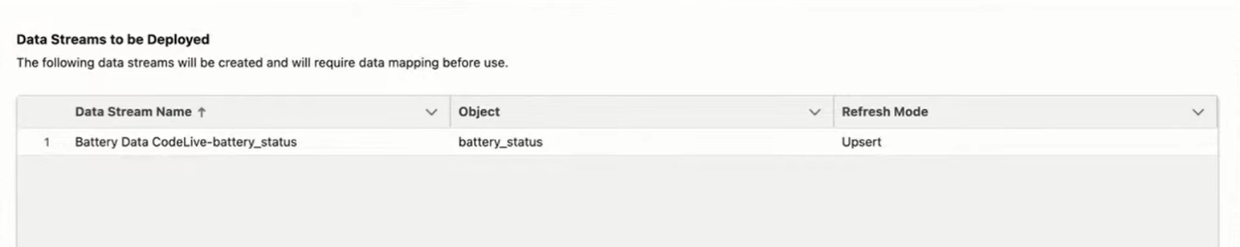

Now integrate with this data and push the data in order to do that we need to create a connected App

- Create a Connected App for Data 360 Ingestion API.

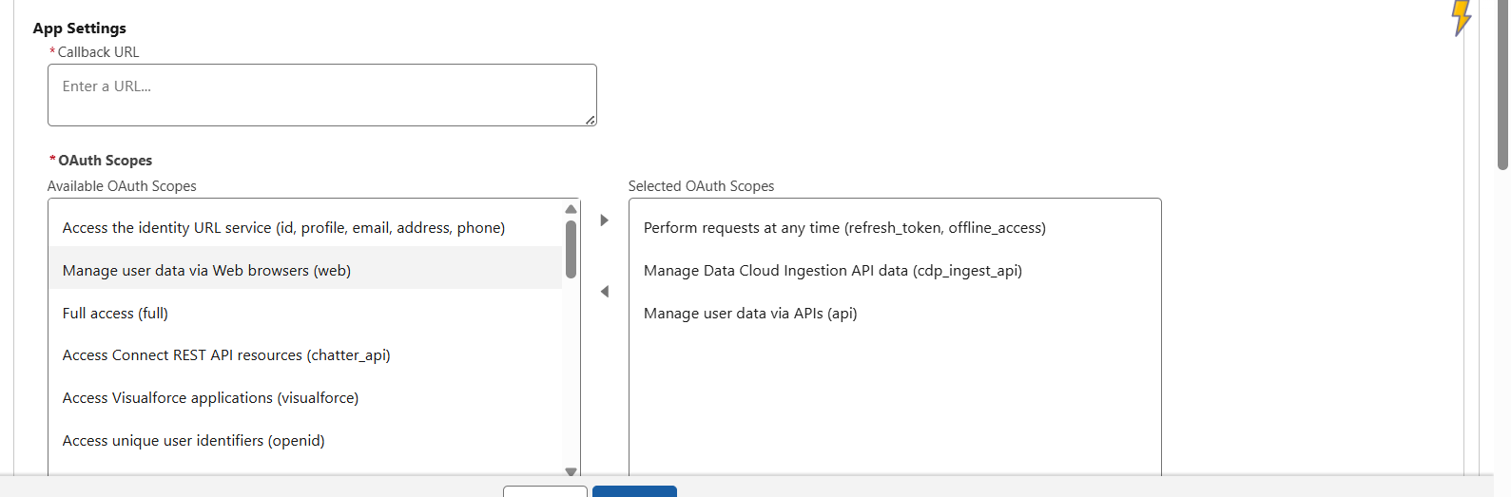
Enter the callback URL (endpoint) that Salesforce calls back to your application during OAuth. It’s the same as the OAuth redirect URI.
Depending on which OAuth flow you use, the URL is typically the one that a user’s browser is redirected to after successful authorization.
Because this URL is used for some OAuth flows to pass an access token, the URL must use secure HTTPS or a custom URI scheme.
If you enter multiple callback URLs, at run time Salesforce matches the callback URL value specified by the app with one of the values in Callback URL. It must match one of the values to pass validation. Separate multiple callback URLs with line breaks. The callback URL field has a limit of 2000 characters, cumulatively. If you enter several URLs and they exceed this limit, create another connected app to manage more callback URLs.

Send data in the JSON format (d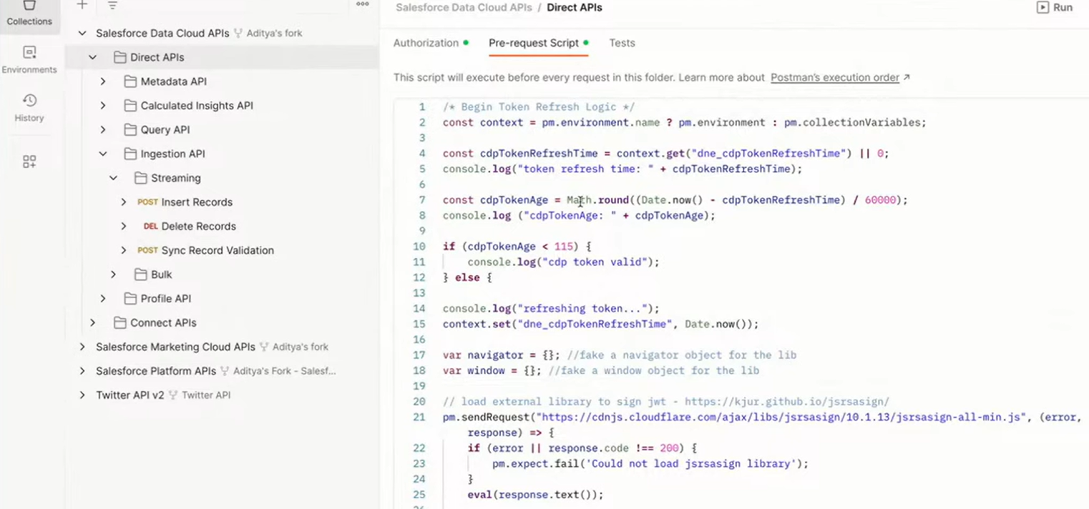ata array), it has to follow the schema that we have defined

